EXPERIMENT 3

Create a Web Page for College Timetable: Use of Tables with Rowspan, Colspan, Headers, Captions, and Nested Tables.

Objectives
- To design a college timetable webpage using HTML tables.
- To apply rowspan and colspan attributes for merging cells.
- To use table headers (<th>), captions (<caption>), and formatting for readability.
- To implement nested tables within a timetable cell.
Tools Required
- Computer / Laptop with any OS
- Text Editor (VS Code, Sublime Text, Notepad++)
- Web Browser (Chrome, Edge, Firefox)
- Internet connection (for YouTube embedding)

Theory
- Table (<table>): Arranges data in rows and columns.
- Rowspan: Merges a cell vertically across rows.
- <td colspan=”3”>Lab</td>
- Colspan: Merges a cell horizontally across columns.
- <td colspan=”3”>Break</td>
- Header (<th>): Displays header cells in bold and centered.
- Caption(<caption>) : Defines the title of the table .
- Nested Table : A Table placed inside another table cell .

CODE IMPLEMENTATION

<html crxlauncher=""><head>

<title>College Time Table</title>

<style>

body {

font-family: Arial, sans-serif;

margin: 0;

height: 100vh;

display: flex;

justify-content: center;

align-items: center;

background-image: url('https://wallpapercave.com/wp/wp15147594.webp');

background-size: cover;

background-position: center;

background-repeat: no-repeat;

position: relative;

color: #161616;

}

.container {

position: relative;

z-index: 1;

width: 90%;

max-width: 1000px;

text-align: center;

}

h1 {

margin-bottom: 20px;

font-weight: 700;

font-size: 2.5em;

}

table {

border-collapse: collapse;

width: 100%;

box-shadow: 0 0 10px rgba(0,0,0,0.15);

background: white;

margin: 0 auto;

}

th, td {

border: 1px solid #f0b5b5;

padding: 10px;

text-align: center;

vertical-align: middle;

transition: background-color 0.3s ease;

}

th {

background: #eaeaea;

font-weight: 600;

}

tbody td:hover {

background-color: #d0e8ff;

cursor: pointer;

}

.yellow { background: #F4C542; }

.green { background: #A3C993; }

.blue { background: #5CC4E6; }

.darkGreen { background: #12C281; }

.gray { background: #CED2D2; }

.lightYellow { background: #EFE143; }

.salmon { background: #FFD7B5; }

.peach { background: #FFD39B; }

.teal { background: #61C47F; }

.lunch { background: #ffffff; font-weight: bold; }

</style>

<style></style></head>

<body>

<div class="container">

<h1>Time Table</h1>

<table>

<tbody><tr>

<th>Time/Day</th>

<th>I<br>08:50-09:40</th>

<th>II<br>09:40-10:30</th>

<th>III<br>10:40-11:30</th>

<th>IV<br>11:30-12:20</th>

<th>V<br>12:20-1:10</th>

<th>VI<br>01:10-02:00</th>

<th>VII<br>02:00-02:50</th>

<th>VIII<br>02:50-03:40</th>

<th>IX<br>03:40-04:30</th>

</tr>

<tr>

<td>Monday</td>

<td class="lightYellow">25AH101<br>(SHA)<br>RJ-206</td>

<td class="yellow">25AS102<br>(Rk)<br>RJ-206</td>

<td class="green">25AS101<br>(VS)<br>RJ-206</td>

<td class="blue">25EL101<br>(PRM)<br>RJ-206</td>

<td class="lunch" rowspan="5">LUNCH</td>

<td class="peach" colspan="2">25CS151<br>(ALA)<br>RJ-303</td>

<td class="yellow">25AS102<br>(RK)<br>RJ-303</td>

<td class="darkGreen">25AS103<br>(DSH)<br>RJ-303</td>

</tr>

<tr>

<td>Tuesday</td>

<td class="green" colspan="2">25AS151<br>(VS,YT)<br>KC-310</td>

<td class="green">25AS101<br>(VS)<br>RJ-206</td>

<td class="yellow">25AS102<br>(Rk)<br>RJ-206</td>

<td class="blue">25EL101<br>(PRM)<br>RJ-206</td>

<td class="yellow">25AS102<br>(RK)<br>RJ-206</td>

<td class="lightYellow">25AH101<br>(SHA)<br>RJ-206</td>

<td class="gray">Mentor-Mentee<br>(DSH-PRM)<br>RJ-206</td>

</tr>

<tr>

<td>Wednesday</td>

<td class="yellow">25AS102<br>(RK)<br>RJ-305</td>

<td class="darkGreen">25AS103<br>(DSH)<br>RJ-305</td>

<td class="salmon" colspan="2">25ME152<br>(DRK,VKS)<br>RJ-109</td>

<td class="lightYellow">25AH101<br>(SHA)<br>RJ-206</td>

<td class="green" >25AS101<br>(VS)<br>RJ-206</td>

<td class="blue">25EL101<br>(PRM)<br>RJ-206</td>

<td class="lunch"></td>

</tr>

<tr>

<td>Thursday</td>

<td class="peach" colspan="2">25CS101<br>(ALA)<br>RJ-207</td>

<td class="yellow">25AS102<br>(RK)<br>RJ-207</td>

<td class="green">25AS101<br>(VS)<br>RJ-207</td>

<td class="gray" colspan="2">25VA151<br>(MN)<br>KC-509</td>

<td class="blue">25EL101<br>(PRM)<br>RJ-305</td>

<td class="darkGreen">25AS103<br>(DSH)<br>RJ-305</td>

</tr>

<tr>

<td>Friday</td>

<td class="blue" colspan="2">25EL101<br>(PRM,AB)<br>RJ-BASEMENT</td>

<td class="blue">25EL101<br>(PRM)<br>RJ-204</td>

<td class="gray" >25VA151<br>(MN)<br>RJ-204</td>

<td class="green" >25AS101<br>(VS)<br>RJ-207</td>

<td class="yellow">25AS102<br>(RK)<br>RJ-207</td>

<td class="peach" colspan="2">25CS101<br>(ALA)<br>RJ-207</td>

</tr>

</tbody></table>

</div>

</body></html>

OUTPUT

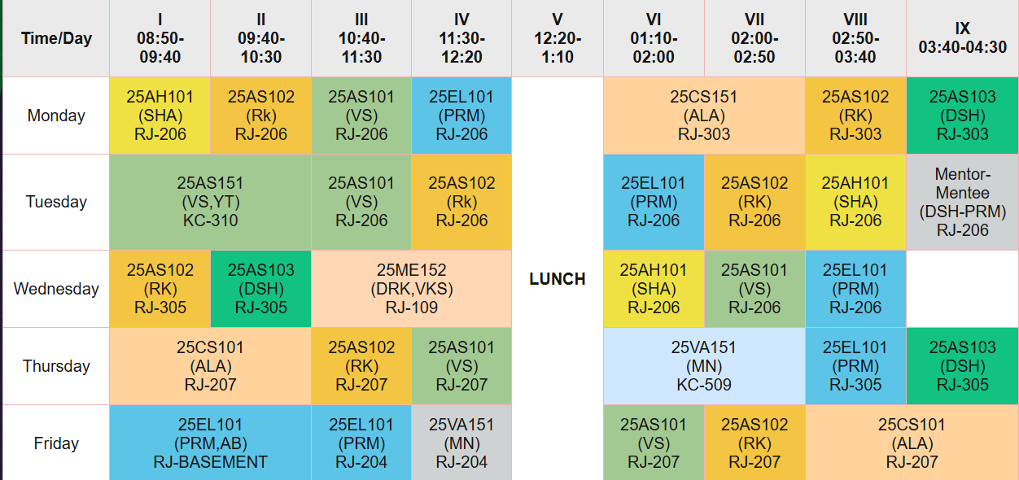

Outcome
- Successfully created a college timetable webpage using HTML tables.
- Implemented rowspan, colspan, headers, captions, and nested tables.
- Learned to organize tabular data in a structured webpage format.

